A Preliminary Analysis on Longitudinal Effects of Exam Stress and Personality Traits over Acoustic Properties
Authors list

¹Department of Information Engineering, Università degli Studi di Firenze, Firenze, Italy
²Institution/Department, Affiliation, City, Country
{federico.cala, ilaria.colpizzi, claudia.mafredi, antonio.lanta, claudio.sica, corrado.caudek, lorenzo.frassineti}@unifi.it
{juuu

Abstract: In recent years, the combination of physiological and psychological domains has gained increasing interest for capturing emotional and stress-related changes, especially through quantitative analysis of voice and speech. This study explores the relationship between personality traits and stress-induced vocal alterations within an Ecological Momentary Assessment (EMA) framework. Thirty-six male undergraduate students completed baseline assessments of personality traits (PID-5) and provided voice recordings before and after an academic exam. Acoustic analyses focused on sustained vowels and a standardized sentence, extracting acoustic features and mel-frequency cepstral coefficients. The results revealed significant vocal changes, including increased fundamental frequency, alterations in articulation and prosody, along with distinct acoustic patterns associated with higher scores in specific PID-5 dimensions. These preliminary findings suggest that integrating psychological and physiological data can enhance the understanding and monitoring of emotional states and stress responses, paving the way for future development of acoustic quantitative analysis within EMA paradigms as a tool to support identification of potential voice-based biomarkers for stress and psychopathology vulnerability.
Keywords: EMA, BoiVoice, MFCC, psychological traits, PID-5

I. INTRODUCTION

Traditional evaluations of psychological states have predominantly relied on self-report questionnaires, clinical interviews, and behavioral observations. These methods provide valuable insights; however, they may suffer from some drawbacks such as low dimensionality, reporting biases and recall limitations [1]. On the other hand, physiological measurements offer objective and robust markers that, if combined with psychometric measures, can better describe emotional responses. Beyond heart rate variability and electrodermal activity, which require contact between the skin and the recording wearable device, voice and speech acquisitions are cost-effective, contactless and can be performed with ubiquitous instruments such as smartphones [2]. Speech can easily deteriorate during situations that demand challenging human performance. Thus, acoustic analysis has experienced a constantly growing interest as a supportive assessment technique for emotion and mood disruption and disorders, among which stress [3]. Specifically, it can be hypothesized that individuals characterized by dysfunctional personality traits, such as high levels of negative affectivity or disinhibition as assessed by the Personality Inventory for DSM-5 (PID-5) [4], may display a personality configuration more prone to psychopathological outcomes. However, the relationship between stable dysfunctional personality traits and stress-induced vocal alterations remains poorly understood, especially regarding their potential role as markers of vulnerability to psychopathology. Furthermore, the possibility of investigating, through quantitative analysis, how the physiological and psychological domains vary together along with their associated temporal dynamics represents a potential area for improvement in voice and speech analysis.
To address this gap, we conducted a study in which dysfunctional personality traits were measured at baseline, while negative emotional states and vocal markers were assessed before and after an ecologically valid stressor, i.e., an academic examination.

II. METHODS

Participants were undergraduate psychology students at the University of Florence, recruited through university advertisements. Participation was voluntary, and inclusion criteria required participants to be at least 18 years old, proficient in Italian, experienced with smartphones, and free from current or past psychiatric disorders or substance addictions.
As a baseline psychological evaluation (hereinafter referred to as the baseline assessment), participants completed the PID-5 questionnaire to assess dysfunctional personality traits [5]. The PID-5 is a self-report instrument consisting of 220 items organized into five domains: Antagonism (A), Detachment (De), Negative Affectivity (NA), Disinhibition (Di), and Psychoticism (P). In addition, participants were trained to use the m-Path mobile application [6], a smartphone-based tool for Ecological Momentary Assessment (EMA) data collection. EMA is a methodology that captures psychological phenomena as they occur in daily life, thereby reducing recall bias, and is therefore particularly useful for assessing stress-related processes and emotional dynamics in naturalistic contexts [7]. Through m-Path, participants received smartphone notifications scheduled once per day on two non-consecutive days per week over a three-month period. Prompts were delivered between 6:00 and 8:00 PM and included affect ratings and brief self-report items. In addition, two exam-related prompts were administered immediately before and after an academic examination. On these occasions, participants were also asked to provide short voice recordings via their smartphones. The recording protocol included three repetitions of the sustained Italian cardinal vowels /a/, /i/ and /u/ for at least 3s, a coarticulation task consisting in listing the number from 1 to 10 and standardized constantly voiced sentence “io amo le aiuole della mamma” (English translation: “I love mother’s flowerbeds”). Participants were instructed to perform such recordings with conversational pitch and loudness, in quiet rooms, keeping the smartphone’s microphone at a fixed distance of 15cm from their mouth and angled at 45° to reduce lateral distortions [8]. Individuals with <50% compliance to EMA prompts were excluded. The final sample comprised 556 participants. As a preliminary analysis, this work focused on the sole male subsample, consisting of 36 subjects (mean age = 22.6 ± 2.8 years old) that completed the assessments for the baseline, pre- and post-exam conditions, and considered the sole PID-5.
Audio recordings were automatically partitioned in 20 segments, containing each repetition of the three cardinal vowels, each number and the standardized sentence. Only the firsts and the latter segments were considered for further analysis in this preliminary study.
Sustained vowels were processed through the open-source BioVoice software [9], which extracted 37 parameters from both frequency and time domains (e.g., fundamental frequency F0, jitter, voiced unit duration). Indeed, an increase of F0 has been recognized as one of the most prominent effects of an altered psychological status [3].
The acoustic properties of the standardized sentence were quantified by the mel-frequency cepstral coefficients (MFCCs). These parameters are known to approximate the human auditory system’s response [10]. Recently, they have been implemented to capture emotional activation and alterations in several experimental paradigms [10,11,12]. The MFCC extraction pipeline was developed in MATLAB 2023a (The Mathworks, Naticks, MS, USA): it computed 13 measures through a per-frame approach, specifically with 25ms long windows and 15ms overlap [10]. The resulting array was then synthesized considering the following statistical metrics: mean, standard deviation (std), median, interquartile range (IQR), skewness, kurtosis, 25th and 75th percentiles.
Each acoustic parameter underwent a repeated measure ANOVA, with the α level of significance set at 0.05 to detect possible alterations between the baseline, pre- and post-exam conditions. In case of significant differences, multiple comparisons were performed across groups with Tukey-Kramer correction. Moreover, accounting for the median value of each PID-5 subscale, data from pre- and post-exam conditions were divided into two groups characterized by lower and higher psychometric scores. A statistical comparison was performed between groups to uncover possible interactions linking psychological traits and acoustic features (α = 0.05).

III. RESULTS

Mean and standard deviation (in parentheses) for each of the PID-5 dimension were: A = 0.73 (0.25), De = 1.08 (0.37), Di = 1.02 (0.32), NA = 1.08 (0.39), P = 0.97 (0.39).
The repeated measures ANOVA on acoustic features highlighted four statistically significant differences for the sustained vowels between the three conditions, specifically F0 median /i/, signal duration /i/, F0 mean /u/ and F1 minimum /u/, as Figure 1 displays.
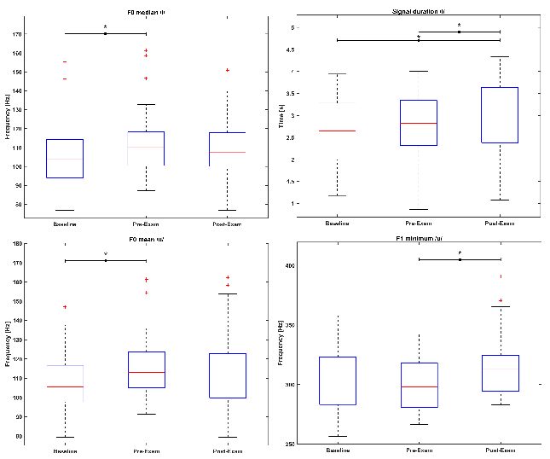
Figure 1: Boxplots for the sustained vowels’ significant differences. A ● represents a p-value < 0.05, whereas a (*) to an effect size d < 0.5
As far as the standardized sentence is concerned, statistical analysis found 11 significant differences across MFCC parameters. Figure 2 shows their distribution.
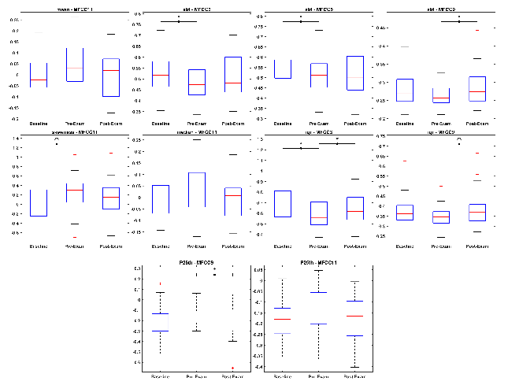
Figure 2: Boxplots for the sustained vowels’ significant differences. A ● represents a p-value < 0.05. A (*) to an effect size d < 0.5, whereas (**) to d < 0.8.
The analysis between the populations with low and high values of the single PID-5 dimensions highlighted several significant differences. Here, only acoustic parameters that presented an alteration in both pre- and post-exam conditions are reported. Subjects with low Detachment values presented a significantly higher value for T0 (F0 max) /a/, i.e., the time instance at which the F0 maximum occurs, and a lower F0 std /u/ before the exam (p_{pre} = 0.047 and p_{pre} = 0.029, respectively). After it, the same parameters preserved the same effect direction (p_{post} = 0.027 and p_{post} = 0.045, respectively). For the Antagonism dimension, MFCC3 mean was significantly higher in both pre- and post-exam conditions in subjects with higher Antagonism scores (p_{pre} = 0.030 and p_{post} = 0.027).
Finally, MFCC4 median was found to be significantly higher in participants with higher values of the Psychoticism dimension (p_{pre} = 0.026 and p_{post} = 0.0089).

IV. Discussion

In this study, a preliminary analysis was conducted to investigate whether, and how, an individual's acoustic properties vary not only in response to stressful events but also according to intrinsic psychological traits.
Indeed, as also reported in [1, 13], the intrinsic information of the human voice demonstrated that under specific cognitive or psychological conditions, e.g., university exams, voice and speech parameters change due to an overall increased sympathetic activity. Unlike spontaneous speech, sustained vowels and standardized sentences provide a proper repeatability framework to study stressors’ influence on vocal emissions. Moreover, using additional utterances such as /i/ and /u/ allows for a deeper understanding.
In fact, this choice proved to be successful in detecting vocal alterations between the three conditions (as shown in Figure 1). The mean and median value of F0 for /u/ and /i/, respectively, were significantly higher in the stressful condition, i.e., the day before the exam, than in the baseline. This aligns with several other literature works that indicate the F0 as one of the most relevant acoustic markers of an altered psychological status [1,3,12]. It has been hypothesized that stress increases the general degree of muscular tone, also at the larynx level, causing the vocal folds to stretch and vibrate more quickly [3]. Such a hypertonia provokes an alteration in the articulation of /u/, specifically causing the vocal tract to be more closed, as a significantly lower minimum of the F1 underlines during the pre-exam period.
MFCCs provide a useful insight about the shape of the short-term spectral envelope of a vocal emission, condensing details of both low and high frequency components. Several studies successfully implemented these coefficients in emotion, and specifically stress as well, recognition from audio recordings [10,14,15]. Smaller significant standard deviations of MFCC3 and MFCC5 in the pre-exam condition than the baseline one reflect a loss of physiological variability that could be associated with constrained articulators (especially tongue and jaw), thus altered resonances. High frequency components were also significantly less variable in the stressful condition, as the boxplot for MFCC11 shows in Figure 2. Such an alteration may be related to aspiration noise between words rather than consonantal sounds due to the phonetic properties of the used sentence. Interestingly, the IQR detected for MFCC3 a difference also between pre- and post-exam conditions. This suggests a high presence of extreme observations in the studied sample, to which the IQR is less sensitive to, that could be caused by how students cope with such a stressor based on their specific stable dysfunctional personality traits. Nonetheless, the male subsample values from PID-5 questionnaires are consistent with normative data and previously reported findings in non-clinical populations of typical levels of dysfunctional personality traits [16]. By dividing the population with the PID-5 dimensions, it was discovered that some acoustic features may serve as robust biomarkers to differentiate participants with low and high scores of Detachment, Antagonism and Psychoticism in both pre- and post-exam conditions. Indeed, recent neurophysiological evidence showed that personality traits systematically modulate biological stress reactivity across multiple systems, including the hypothalamic–pituitary–adrenal axis, the autonomic nervous system, and immune responses. A high level of Detachment marks blunted emotional reactivity: unsurprisingly, subjects belonging to this category presented an early maximum F0, reflecting a hyperfunctional phonation characterised by abrupt and unstable vocal folds’ adduction. On the other hand, Psychoticism can be related to perceptual dysregulation and Antagonism to grandiosity: both facets may explain the altered motor-articulatory reflected in the higher MFCC4 and MFCC3 mean parameters [17].

V. Conclusion

Stressful events, e.g., university exams, determine changes in voice and speech properties, which become more evident by taking into account the students’ stable personality traits. Taken together, this outcome supports the hypothesis that voice features can represent a non-invasive technique to explore trait-dependent stress physiology, bridging dimensional models of personality and objective biomarkers of emotional reactivity. While encouraging, these results should be considered preliminary. The associations found between the physiological and psychological domains were derived from a limited cohort and did not account for the dynamic variations at the time points collected in the original study (i.e., EMA at baseline, pre-, and post-conditions). Such aspects will be integrated into future studies to better understand the complex relationship between emotional responses and the physiological characteristics, particularly with regard to longitudinal monitoring of voice and speech. Research will also investigate the impact of demographic factors (e.g., age, gender, exam mark) and include psychophysiological data from longer monitoring periods.

REFERENCES

[1] Wang, Q., …, & Liu, X. (2025). How Anxiety State Influences Speech Parameters: A Network Analysis Study from a Real Stressed Scenario. Brain Sci, 15(3), 262.
[2] Manfredi, C., …, & DeJonckere, P. H. (2017). Smartphones offer new opportunities in clinical voice research. J Voice, 31(1), 111-e1.
[3] Giddens, C. L., …, & Winter, A. S. (2013). Vocal indices of stress: a review. J Voice, 27(3), 390-e21.
[4] Krueger, R. …, & Skodol, A. E. (2012). Personality inventory for DSM-5. Psychiatry Res
[5] Lovibond, P. F., & Lovibond, S. H. (1995). The structure of negative emotional states: Comparison of the Depression Anxiety Stress Scales (DASS) with the Beck Depression and Anxiety Inventories. Behav Res Ther, 33(3), 335–343.
[6] Mestdagh, M., ..., & Dejonckheere, E. (2023). M-path: An easy-to-use and highly tailorable platform for ecological momentary assessment and intervention in behavioral research and clinical practice. Front Digit Health, 5, 1182175.
[7] Trull, T. J., & Ebner-Priemer, U. W. (2020). Ambulatory assessment in psychopathology research: A review of recommended reporting guidelines and current practices. J Abnorm Psychol, 129(1), 56.
[8] Calà, F., Frassineti, L., ... & Zampino, G. (2023). Artificial intelligence procedure for the screening of genetic syndromes based on voice characteristics. Bioengineering, 10(12), 1375.
[9] Morelli, M. S., Orlandi, S., & Manfredi, C. (2021). BioVoice: A multipurpose tool for voice analysis. Biomed Signal Process Control, 64, 102302.
[10] Kim, S., Kwon, N., …& Bartlett, M. (2020, July). "How are you?" Estimation of anxiety, sleep quality, and mood using computational voice analysis. IEEE EMBC 2020
[11] Olah, J., … & Cummins, N. (2023). Online speech assessment of the psychotic spectrum: exploring the relationship between overlapping acoustic markers of schizotypy, depression and anxiety. Schizophr Res, 259, 11-19.
[12] König, A., …& Robert, P. (2021). Measuring stress in health professionals over the phone using automatic speech analysis during the COVID-19 pandemic: observational pilot study. J Med Internet Res, 23(4), e24191.
[13] Pisanski, K., Nowak, J., & Sorokowski, P. (2016). Individual differences in cortisol stress response predict increases in voice pitch during exam stress. Physiol Behav, 163, 234-238.
[14] Nordin, M. S., …& Azmin, N. F. M. (2022, November). Stress Detection based on TEO and MFCC speech features using Convolutional Neural Networks (CNN). IEEE ICOCO 2022.
[15] Narzary, D., & Sharma, U. Analysis of Mental Stress with Machine Learning Methods. Springer ICICC 2024.
[16] Miller, J. D., … & Lynam, D. R. (2022). Normative data for PID-5 domains, facets, and personality disorder composites from a representative sample and comparison to community and clinical samples. PD:TRT, 13(5), 536.
[17] Soliemanifar, O., Soleymanifar, A., & Afrisham, R. (2018). Relationship between personality and biological reactivity to stress: a review. Psychiatry Investig, 15(12), 1100.

